**ICT171 – Cloud Server Project**  
**Name:** Usman Javed  
**Student Number:** 35190771  
**Date:** 6/9/2025  
**Public IP Address:** 48.216.241.199  
**Domain Name:** ict171.online  
**GitHub Repo:** <https://github.com/usmanjav-hub/ictusman.git>

**Video Explainer:** [**https://drive.google.com/file/d/1Sr_PItmUuAZrIudylksh7JeXy6ym53w4/view?usp=drivesdk**](https://drive.google.com/file/d/1Sr_PItmUuAZrIudylksh7JeXy6ym53w4/view?usp=drivesdk)

<https://drive.google.com/file/d/1thJkczPzqbLKLCYEgc9zDPsV7zSo7OAq/view?usp=drivesdk>

<https://drive.google.com/file/d/1IKFI7T4HbPK4Ym0gDG5qT0hGkzK_j2c5/view?usp=drivesdk>

<https://drive.google.com/file/d/1IKFI7T4HbPK4Ym0gDG5qT0hGkzK_j2c5/view?usp=drivesdk>

<https://drive.google.com/file/d/1S7uw1pK_6VGt4qbTBguduaWGanuly6Qz/view?usp=drivesdk>

**Introduction**

This project involves deploying a Linux-based web server in Microsoft Azure using Infrastructure as a Service (IaaS). The purpose is to manually set up and document a server capable of hosting a personal website and demonstrate scripting and system automation.

**2. Server Setup**

**2.1 Azure VM Configuration**

* **Resource Group:** ict171-reg
* **VM Name:** myvm
* **Region:** East US (Zone 3)
* **Image:** Ubuntu Server 24.04 LTS
* **Size:** Standard B1s (1 vcpu, 1 GiB memory)
* **Authentication:** SSH Public Key
* **Username:** azureuser
* **Open Ports:** 22 (SSH), 80 (HTTP)

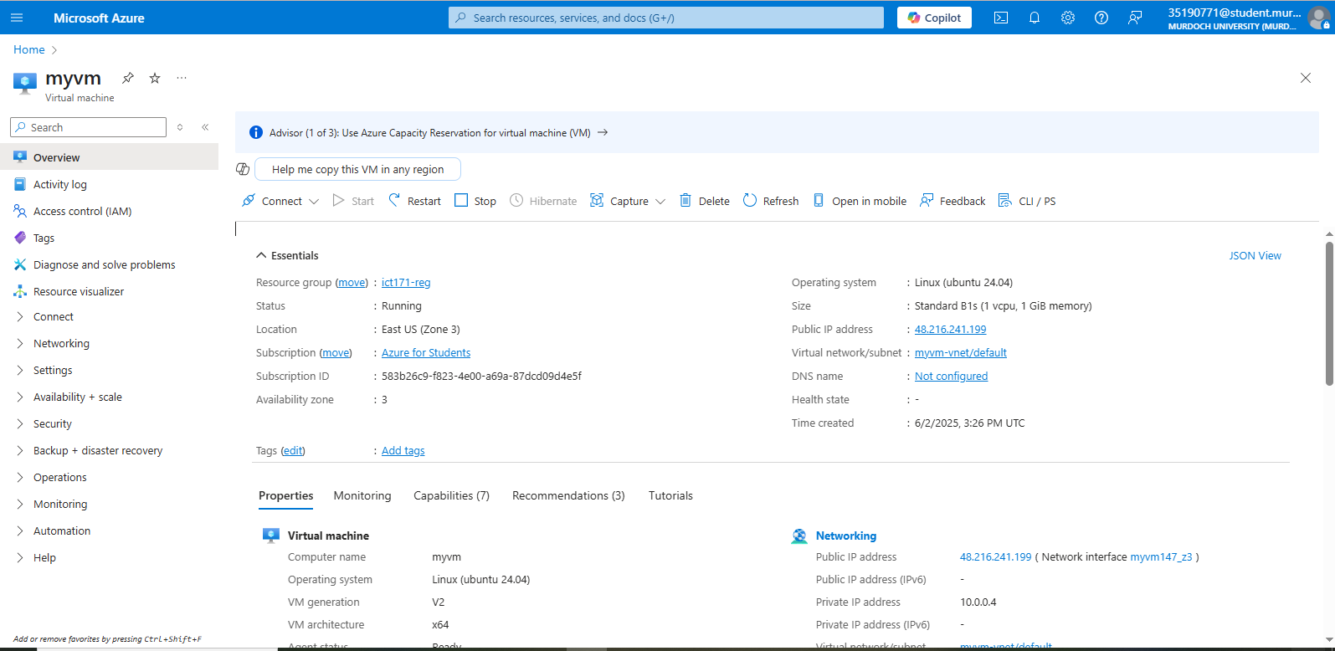

**2.2 SSH Access**

ssh -i azu.pem [azureuser@48.216.241.199](mailto:azureuser@48.216.241.199)

**3. Web Server Installation**

**3.1 Apache Setup**

sudo apt update && sudo apt upgrade -y

sudo apt install apache2 -y

sudo systemctl enable apache2

sudo systemctl start apache2

To verify:

* Visit: http:// 48.216.241.199 or https://ict171.online
* Apache default page should appear.

**New updated page  
**

**4. DNS Configuration**

**4.1 Domain Used**

* Domain Registrar: Go Daddy
* Domain: ict171.online

**4.2 DNS Settings**

| **Type** | **Name** | **Value** |
| --- | --- | --- |
| A | @ | 48.216.241.199 |

DNS propagation may take up to 30 minutes.

**5. Scripting: Web Content Backup Script**

**1. Script Explanation**

This Bash script (backup_website.sh) automates daily backups of your portfolio website's content and Apache configuration. It:

* Creates timestamped backups
* Compresses files into .tar.gz format
* Stores backups in /var/backups/website/
* Keeps only the 7 most recent backups
* Logs all operations

#!/bin/bash

*# Website Backup Script for ICT171 Assignment*

*# Purpose: Automatically backs up web content and Apache config*

*# Configuration*

BACKUP_DIR="/var/backups/website"

LOG_FILE="/var/log/website_backup.log"

WEB_ROOT="/var/www/html"

APACHE_CONF="/etc/apache2"

KEEP_BACKUPS=7

*# Create backup directory if missing*

mkdir -p "$BACKUP_DIR"

*# Generate timestamp*

TIMESTAMP=$(date +"%Y%m%d_%H%M%S")

BACKUP_FILE="$BACKUP_DIR/backup_$TIMESTAMP.tar.gz"

*# Perform backup*

echo "$(date) - Starting backup" >> "$LOG_FILE"

tar -czf "$BACKUP_FILE" "$WEB_ROOT" "$APACHE_CONF" 2>> "$LOG_FILE"

*# Clean old backups*

ls -t "$BACKUP_DIR"/backup_*.tar.gz | tail -n +$(($KEEP_BACKUPS + 1)) | xargs rm -f

*# Verify and log*

if [ -f "$BACKUP_FILE" ]; then

echo "$(date) - Backup successful: $BACKUP_FILE" >> "$LOG_FILE"

else

echo "$(date) - Backup failed!" >> "$LOG_FILE"

fi

**2. How to Use**

**Installation**

1. **Save the script:**

sudo nano /usr/local/bin/backup_website.sh

1. **Make it executable:**

sudo chmod +x /usr/local/bin/backup_website.sh

**Manual Execution**

sudo /usr/local/bin/backup_website.sh

**Automate with Cron (Daily Backups)**

1. **Open crontab:**

sudo crontab -e

1. **Add this line (runs daily at 2 AM):**

0 2 * * * /usr/local/bin/backup_website.sh

**3. How to Verify**

**Check Backup Files**

ls -lh /var/backups/website/

**Sample output:**

-rw-r--r-- 1 root root 12M Jul 10 02:00 backup_20250710_020001.tar.gz

-rw-r--r-- 1 root root 11M Jul 9 02:00 backup_20250709_020001.tar.gz

**Verify Backup Contents**

tar -tzf /var/backups/website/latest_backup.tar.gz | head -10

**Check Logs**

tail -5 /var/log/website_backup.log

**Sample output:**

Mon Jul 10 02:00:01 UTC 2025 - Starting backup

Mon Jul 10 02:00:12 UTC 2025 - Backup successful: /var/backups/website/backup_20250710_020001.tar.gz

**6. GitHub Repository**

📁 GitHub: <https://github.com/usmanjav-hub/cloud-server-ict171>

Contents:

* backup_web_content.sh
* README.md
* PDF documentation
* Screenshots

**7. Video Explainer**

Covers:

* VM setup
* SSH access
* Apache install
* DNS setup

**8. Troubleshooting and Lessons Learned**

* **Issue:** DNS A record delay  
  **Solution:** Waited 30–60 minutes before retrying
* **Issue:** SSH timed out  
  **Solution:** Checked Network Security Group settings to allow port 22
* **Lesson Learned:** Azure makes it easy to configure but still requires careful handling of firewall rules and scripts.

**9. References**

* DigitalOcean Docs: https://www.digitalocean.com/community/tutorials
* Apache Ubuntu Setup: <https://ubuntu.com/server/docs/web-servers-apache>
* Azure VM Docs: <https://learn.microsoft.com/en-us/azure/virtual-machines/>
* Crontab Guru: <https://crontab.guru>